School District NGSS Transition Plan Template

Introduction

This document is intended to help guide school districts as they plan for the transition from Connecticut State Science Curriculum Standards to Next Generation Science Standards (NGSS). This template was created in accordance with the Principles for Implementation from the National Research Council’s Guide to Implementing the Next Generation Science Standards (2015), including:

1. Ensure coherence across levels (state, district, schools), across grades, and across different components of the system—curriculum, assessment, instruction, and professional development.

2. Attend to what is unique about science.

3. Develop and provide continuing support for leadership in science at the
state, district, and school levels.

4. Build and leverage networks, partnerships, and collaborations.

5. Take enough time to implement well.

6. Make equity a priority.

7. Ensure that communication is ongoing and relevant.

The template is best utilized as a starting point for discussion and decision-making among district leadership and stakeholders as they plan an incremental and coherent transition that provides support for educators and students during the shifts in curriculum and instructional practice.

Districts can adapt the template or develop an alternative model to suit their particular needs.

Evaluation of Current Program

Districts may choose to begin their transition planning by evaluating their current K-12 science programs. An effective tool for this task is the NGSS Primary Evaluation of Essential Criteria for Alignment (PEEC) (http://nextgenscience.org/ngss-peec-alignment). PEEC (in draft form) is intended to evaluate the NGSS alignment of science programs as a whole. Evaluation of specific instructional units and lessons can be accomplished using the EQuIP rubric (http://www.nextgenscience.org/resources).

Guiding Strategies for NGSS Transitions

Following are the recommended overall strategies for guiding the NGSS transition:

1. Facilitate high quality professional learning opportunities for educators to ensure that every student has access to teachers who are prepared to teach and facilitate student learning to the levels of rigor and depth required by NGSS.

2. Develop NGSS-aligned instructional resources designed to meet the diverse needs of all students.

3. Develop and transition to NGSS-aligned assessments that supports the improvement of teaching and learning in support of student achievement and provide information that may be used for program evaluation.

4. Collaborate with all stakeholders (teachers, administration, Board of Education, and community) to ensure successful and full integration of NGSS into programs across the K-12 curriculum.

Key Components of NGSS Transitions

Along with the strategies, these key components help establish a timeline:

The awareness element includes a review of current program goals along with an introduction to NGSS core principles for all stakeholders, consideration of the anticipated systems of professional learning and curriculum revision, and identification of evaluation metrics.

The transition element focuses on building enduring systems and resources for curricular revision and professional learning, development of next generation assessments supporting a fully aligned curriculum, and maintaining collaborations between stakeholders.

The implementation element supports ongoing professional learning and coaching, develops NGSS-aligned instructional resources, ensures fidelity of instruction through data-driven decision making.

State of CT Timeline for NGSS Assessments

The Following table shows a proposed draft for State of CT timeline for NGSS transition:

 | SPRING 2016 | SPRING 2017 | SPRING 2018 | SPRING 2019
CMT:  GRADES 5 AND 8  CAPT:  HIGH SCHOOL | ALIGNED  TO  CT SCIENCE  STANDARDS | ALIGNED  TO  CT SCIENCE  STANDARDS | ALIGNED  TO  CT SCIENCE  STANDARDS | INAUGURAL  NGSS  ALIGNED  ASSESSMENT
NGSS  ASSESSMENT  DEVELOPMENT | NGSS  ITEM  PILOTING | NGSS  ITEM  PILOTING  &  READINESS  REPORTING | NGSS  ITEM  PILOTING  &  READINESS  REPORTING | ONGOING ADMINISTRATION AND  REPORTING

Templates

Taking into account the four Guiding Strategies, as well as the assessment timeline proposed by the Connecticut State Department of Education, there are five “timeframes” to immediately consider for the transition:

2015-2016
2016-2017
2017-2018
2018-2019
Ongoing Efforts beyond 2019

Ideally, each Guiding Strategy should be considered within each year.

The element(s) of a Strategy for a given timeframe may fall under the category of Awareness, Transition, or Implementation depending on the context. There are many possible ways to visualize this depending on the specific needs of the district.

The following template demonstrates one way to visualize a district’s needs during the transition to NGSS:

2015-2016
 | Awareness | Transition | Implementation
Professional Learning
Instructional Resources
Assessments
Collaboration

2016-2017
 | Awareness | Transition | Implementation
Professional Learning
Instructional Resources
Assessments
Collaboration

2017-2018
 | Awareness | Transition | Implementation
Professional Learning
Instructional Resources
Assessments
Collaboration

2018-2019
 | Awareness | Transition | Implementation
Professional Learning
Instructional Resources
Assessments
Collaboration

Ongoing NGSS-Related Efforts (2019+)
 | Awareness | Transition | Implementation
Professional Learning
Instructional Resources
Assessments
Collaboration

An alternate way to visualize the transition is to color-code the elements by their corresponding key components. This format allows the reader to see how each key component evolves over the course of the five years. An example follows with several transition activities illustrated:

(see next page)

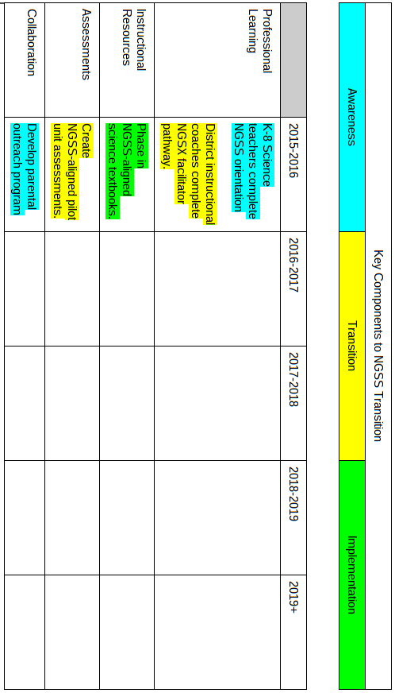

Considerations When Planning Each Element

- What are our goals?
- Who are the stakeholders?
- What actions can stakeholders take to move toward the goal?
- How will we know when the goal has been achieved?

Stakeholders May Include…

- Students
- Parents
- Science teachers
- Special education teachers
- Classroom teachers in other STEM fields
- Instructional coaches
- Building administrators
- District administrators
- Board of Education
- Informal STEM educators (children's museums, nature centers, etc.)
- STEM-oriented businesses

Example

To provide examples of some of the elements that will likely play a role in districts’ NGSS transitions and how they would be organized within a chart such as the one shown above, a partially completed chart for one transitional year is shown following.

This example is not a complete list of possible transition elements and is intended to illustrate only a few of the variety of elements necessary for a comprehensive NGSS transition plan.

2018-2019
(Example)
 | Awareness | Transition | Implementation
Professional Learning | Goal: Guidance staff familiar with NGSS to facilitate informed course selection.  Stakeholders: Guidance staff, district science leadership.  Action: Hold NGSS workshop for guidance staff.  Achievement: Guidance staff can describe shifts in course content, expectations for students in NGSS-aligned courses. | Goal: Newly hired K-5, 6-12 science teachers are NGSS-ready  Stakeholders: Incoming teachers, NGSX facilitators, instructional coaches  Action: NGSX teacher pathway completed by all incoming K-5, science teachers  Achievement: 100% of K-5, science teachers have completed NGSX teacher pathway
Instructional Resources |  | Goal: Develop NGSS-aligned units to implement during 2018-2019 school year.  Stakeholders: Science Curriculum Committee  Action: Leverage summer workshops to develop NGSS-aligned units following K-5/6-8/9-12 learning progression for grades K,1,7, 11/12) (finalize units for grades 3,5,6,10).  Achievement: NGSS-transitioned units and assessments for grades K,1,7, 11/12.  Goal: Support implementation of NGSS-aligned units with appropriate resources and materials.  Stakeholders: Science Curriculum Committee.  Actions: Research, evaluate and acquire resources for NGSS-aligned units.  Achievement: Acquisition of materials to support 3 Dimensional learning. | Goal:Full K-12 implementation of NGSS-aligned science curriculum  Stakeholders: K-5 teachers, 6-12 science teachers, instructional coaches, building-level administrators  Action: Teachers fully implement NGSS-aligned curriculum and resources  Achievement: Curriculum is implemented with fidelity district-wide according to survey, evaluation data
Assessments | Goal: Parents who can support student achievement on upcoming NGSS-aligned assessments.  Stakeholders: District leadership, building principals, parents of students to be assessed in Spring of 2019.  Action: Each building holds NGSS assessment information night in Fall of 2019 for parents of students to be assessed in Spring of 2019.  Achievement: Parents have improved ability to support student achievement on NGSS-aligned assessments. |  | Goal: Collect data on student achievement on NGSS-aligned assessments  Stakeholders: Science teachers, district science leadership  Action: Implement K-12 NGSS-aligned benchmark assessments  Achievement: Stakeholders analyze student performance and use data to inform instruction
Collaboration | Goal: Support for parental awareness of and participation in NGSS transition.  Stakeholders: District leadership, building principals, parents  Action: Middle and High Schools hold NGSS information sessions for parents of incoming 6th, 9th grade students.  Achievement: Increased community knowledge of NGSS principles and practices across the science program. | Goal: Inform building-level administrators regarding 3D model, aims, formatting, and validity of NGSS aligned assessments.  Stakeholders: District leadership, building administrators.  Action: Facilitate professional learning program for building-level administrators regarding NGSS aligned assessments.  Achievement: Support fidelity of NGSS curriculum implementation leveraging 3D learning model. | Goal: Instructional coaches support teachers during implementation of NGSS-aligned units  Stakeholders: Instructional coaches  Action: Instructional coaches have weekly sessions with grade-level science teams.  Achievement: Teachers make transition to 3 Dimensional learning associated with new NGSS-aligned units.

